Mail is shared 08-08-2022. at 13.35 p.m with the press, and is added with notes and pictures, which is re-sent to everyone listed as recipient.
http://banknyt.dk/08-08-2022-kindly-request-that-for-permission-to-hand-over-full-documentation-to-denmarks-national-bank-that-denmarks-second-largest-bank-jyske-bank-has-committed-mandate-fraud-forgery-of-doc/

Denmarks Nationalbank
Langelinie Allé 47
2100 København Ø
TO the Executive Board of the National Bank of Denmark
At Signe Krogstrup, Lars Rohden and Per Callesen.

Remember that since
2016. when I discover Jyske Bank A/S is committing fraud, using, forging documents, has lied to the court, no one has wanted to talk to me, subsequently only more matters have arisen, such as the use of bribes and violation of the Land Registration Act Section 11. and I have established that Danish judges are also helping to cover up Jyske Bank's crimes.

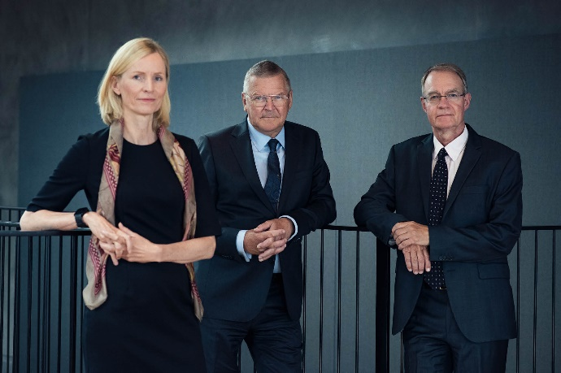
TO the Executive Board of the National Bank of Denmark.
National Bank Director Signe Krogstrup, National Bank Director Lars Rohde, National Bank Director Per Callesen.
Source Denmarks Nationalbank.

A small introduction before I here share the email of 8 August 2022 to the National Bank of Denmark by bank director Lars Rohde.

[caption id="attachment_22663" align="alignnone" width="300"]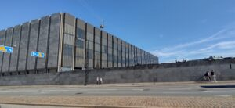
Case of organized fraud carried out by Jyske Bank A/S
[/caption]
A Case and real history of organized fraud carried out by Jyske Bank A/S
And about corruption and organized crime in Denmark, which the Danish state, Denmark's National Bank and the Danish Financial Supervisory Authority as well as the government, the Ministry of Justice and many others have covered up until today.

The case and the company can be taken over, as I want to spend more time writing about corruption and the bribery and abuse of power that governs Denmark.
I have gathered enough material, but here I want to finally get it confirmed whether Denmarks Nationalbank will continue to cover up Jyske Bank criminally, whereby Nationalbank can be complicit in the bank's fraud, this is one of the team actions when I put names of the persons and authorities who have contributed directly or indirectly to Jyske Bank's organized crime.

If there is anyone who wants to support me in my work against corruption, and to write my book.
I would be grateful for any contribution received at.
Label your contribution: STOP Corruption in Denmark.
Registration 5479 account number 0004563376.
IBAN DK0854790004563376.

My book that must be the basis for my complaint against the Danish state, for violating my human rights.

Since the Danish State has effectively undermined my legal certainty, and opposed justice and in that way contributed to Jyske Bank A/S being able to expose me to punishable crime, by being passive, and in this way the Danish State and the government probably have a co-responsibility.
My book is about corruption in Denmark, and complaints about the Danish state.

It depends, of course, whether Denmark's national bank together with the Danish state and government, the Danish politicians who are themselves represented in Denmarks Nationalbank, will act on the information about Jyske Bank's use of crime, or whether the authorities and also the Nationalbank will continue to prevent it from receiving and review my evidence, that Jyske Bank A/S is behind organized crime, and must therefore be deprived of the right to conduct banking business in Denmark.

Or what the authorities think the law prescribes when a bank forges documents, lies in legal matters, commits fraud, uses bribes and much more.
You should kindly note that this could have been avoided by you bothering to talk to me, nobody wanted this, as you have been more busy covering up Jyske Bank's crimes.

Denmark has a major problem not only with the state collaborating with criminal banks, but also with the fact that the Danish authorities have chosen to cover up the criminal Jyske Bank.

My email to Denmarks Nationalbank and its board, management and representative office.

Is exclusionary in order to get clarity about Denmarks Nationalbank, will continue to help cover up the Danish banks that, as Jyske bank, use the bank's power to expose the weak to fraud, when the opportunity presents itself, and when Jyske Bank is discovered, chooses Jyske Bank A/S management to use bribes to get away with fraud.

These are quite outrageous accusations against Jyske Bank A/S.
And it is accusations like these that I am requesting to file with Denmark's national bank, and national bank director Lars Rohde will accept my requests, like the rest of Denmark.

[caption id="attachment_22800" align="alignnone" width="1277"]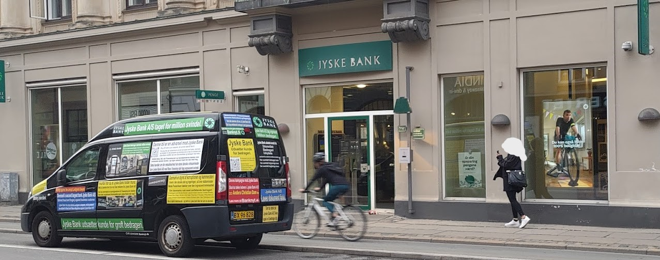 After the first 10 weeks, the Jyske Bank car is parked right outside the door of Jyske Bank A/S Frederiksberg Copenhagen.
Finally back with fresh commercials.
Do you have a good explanation as to why all the authorities and Jyske bank A/S themselves are completely silent,
to Jyske Bank the car that has been driving around since November 2015.
Haven't received a single comment or note from either the Danish authorities who have to keep an eye on the criminal Danish banks.
Or why Jyske Bank itself does not want to speak to the customer who has parked the car right in front of the door of the criminal Danske bank, the customer is simply trying to get in touch with CEO Anders Christian Dam, who has personally refused to speak to the customer since 2016.
Do you have an explanation as to why the Danish state and the government are actually covering up this criminal Danish bank.
Then I would like to hear from you. banknyt@gmail.com[/caption][caption id="attachment_22801" align="alignnone" width="1328"]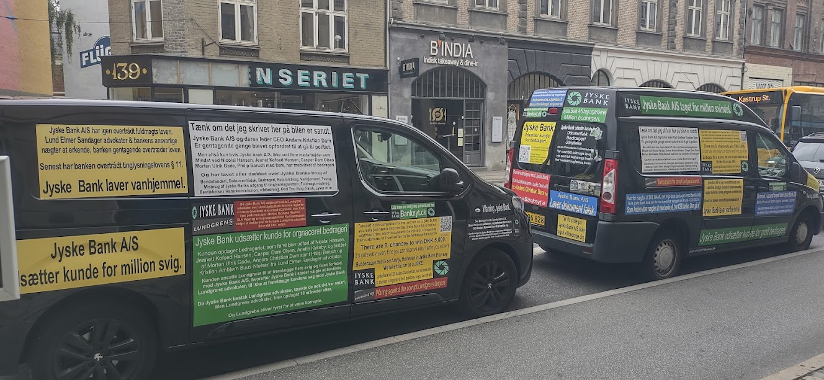 Jyske bank's best weapon against the customers against whom the Bank, together with the board, has carried out a cunning fraud, is total silence, as it is political for the Danish state to cover up Danish banks' use of crime.
In the email 04-08-2022. to Lars Rohde Nationalbank.
Has Denmarks Nationalbank been given the opportunity to be the first to distance itself from Jyske Bank's obvious criminal activities.[/caption]

What do you think this is? Jyske Bank A/S itself, states about the Jyske Bank car that the bank just sees it as a JOKE.
What do you think who is on the board of Denmarks Nationalbank?.
Do you also think this is a joke, I look forward to meeting and presenting my evidence that what is written on the cars is true.

I would like to send my request to present the Denmarks Nationalbanken documentation for my charges against Jyske Bank A/S If I am still becomes ignored, I will send a letter by post instead to you.
National Bank Director Signe Krogstrup, National Bank Director Lars Rohde, National Bank Director Per Callesen.

For use in my upcoming book on organized crime and corruption in Denmark, I want clarity, and with the inquiries to Nationalbank Denmark.
Will the bank's response and action Denmarks Nationalbank will cover up Jyske Bank's criminal actions.

[caption id="attachment_17507" align="alignnone" width="950"]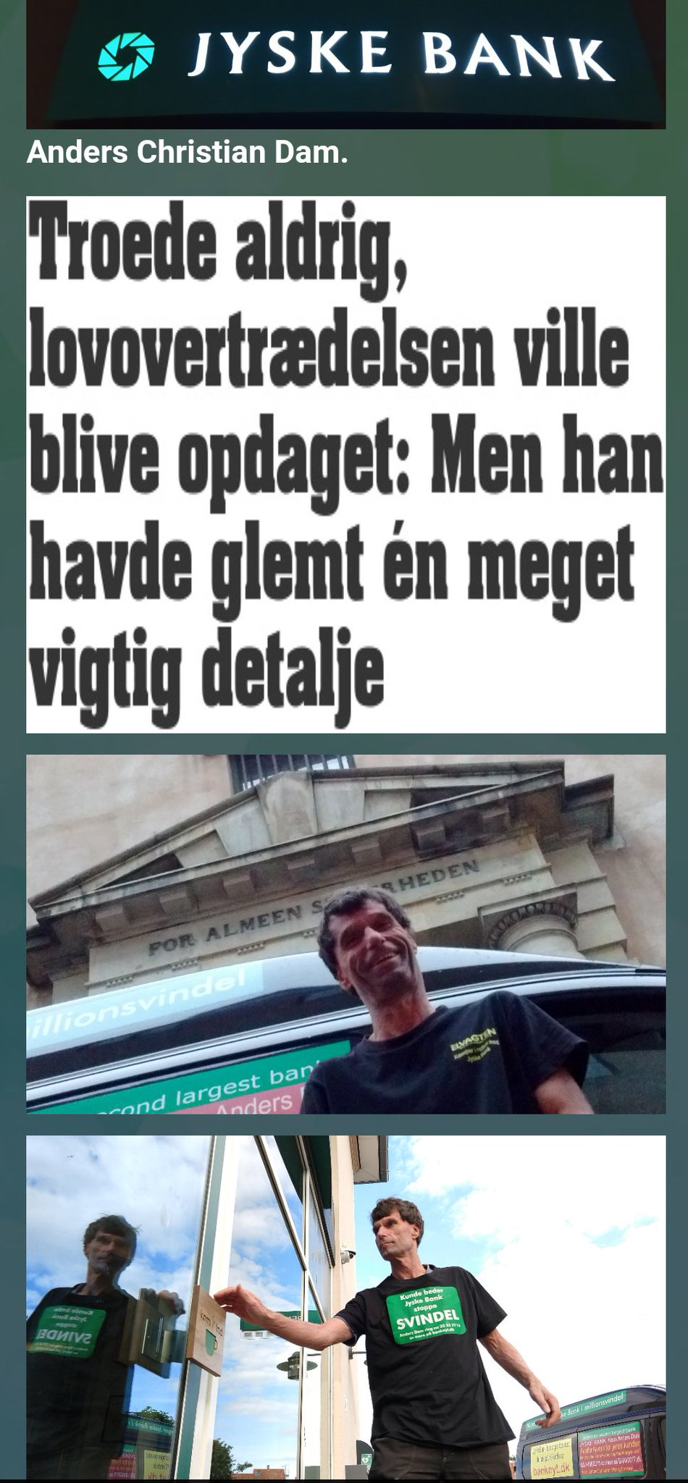
Jyske Bank never believed that the bank's fraud would be discovered, but the bank's criminal gang of members forgot an important detail, and that was that the customer who was seen as an easy victim, as he was critically ill survived and has taken up the fight against criminal banks.[/caption]

Contact Carsten Storbjerg Skaarup on phone +4522227713 if you are interested in taking over the company and or the case alone.
The case against Jyske Bank A/S shows that the Danish state and government are covering up Jyske Bank's crime, and in this way Denmark has become a banana republic that gives the law a damn when the strongest Danish corporations commit fraud against their customers.

I have chosen since 2016 to write openly about the problem of organized crime in Denmark, where Denmark's second largest bank Jyske Bank A/S is behind it.
It is no secret, nor is it that in Denmark only one person has chosen to take up the fight against the corruption and cronyism that is instrumental in creating subversive activities for Danish society, by working against and directly fighting against law and justice.
The problem for Danes' legal security is great when, as in this case, a large organization Jyske Bank A/S, which is part of the power elite, deliberately and dishonestly chooses to expose customers to fraud.

And when the authorities and judges who were supposed to protect and secure the legal certainty of the small town against criminal organizations, find that Danish authorities and politicians disregard the rights of the weak, so that large law firms, employees of the Courts Agency, the prosecution authority, the National Police Chief, the Prime Minister and many more choose to covers Jyske Bank's crimes whereby the Danish state provides legal certainty to cover up banks that, like Jyske Bank, commit serious crimes and even use bribes to cover up the crime Jyske Bank A/S is behind.
I cannot alone stop the corruption that is destructive to Danish society, nor can I win in a Danish court as long as we also have corrupt judges who, like Supreme Court judge Kurt Rasmussen, have also covered up that Jyske Bank A/S bribed the corrupt Lundgren's lawyers to not present the client's case against Jyske Bank A/S

About organized crime in denmark, and the use of corruption and abuse of power to help criminal banks "Jyske Bank A/S.".

sendt 08-08-2022. time. 03.34
Kommunikation <kommunikation@nationalbanken.dk>,
kf@nationalbanken.dk,
nationalbanken@nationalbanken.dk,
anne.paulin@ft.dk,
jakob.ellemann-jensen@ft.dk,
pso@nationalbanken.dk,
lisbeth.bech-nielsen@ft.dk,
kristian.thulesen.dahl@ft.dk,
jens.joel@ft.dk,
sophie.lohde@ft.dk,
sofie.carsten.nielsen@ft.dk,
troels.poulsen@ft.dk,
Justitsministeriet <jm@jm.dk>,
em@em.dk,
dc@em.dk
and mail CC.
IMI-HELPDESK@ec.europa.eu,
info@ecb.europa.eu,
media@ecb.europa.eu,
Justitsministeriet <jm@jm.dk>,
"<NSJ@politi.dk>" <NSJ@politi.dk>,
fm@fm.dk,
finanstilsynet@ftnet.dk,
Statsministeriet <stm@stm.dk>,
folketinget@ft.dk,
REU@ft.dk,
Jura og Forretning <jur@domstolsstyrelsen.dk>,
postkasse@advokatsamfundet.dk,
Postkasse - Klagesagsafdelingen <klagesagsafdelingen@advokatsamfundet.dk>,
saoek@ankl.dk,
SAK@ankl.dk,
kmj@atp.dk,
pernille.vermund@ft.dk,
christian.rabjerg.madsen@ft.dk,
mette.abildgaard@ft.dk,
marlene.ambo-rasmussen@ft.dk,
simon.ammitzboll@ft.dk,
kirsten.normann.andersen@ft.dk,
ida.auken@ft.dk,
liselott.blixt@ft.dk,
morten.messerschmidt@ft.dk,
mads.lebech@apmollerfonde.dk,
media@lego.com,
bankdata@bankdata.dk,
info@loomis.com,
redaktion@borsen.dk,
Arbejderen Redaktion <redaktion@arbejderen.dk>,
ssl@dr.dk,
tv2@tv2.dk,
1234@tv2.dk,
BT-1929 1929 <1929@bt.dk>,
EB 1224 <1224@eb.dk>,
redaktion@midtjyllandsavis.dk,
redaktionen@altinget.dk,
redaktion@tv2lorry.dk,
rune@information.dk,
info@cepol.europa.eu,
chefredaktionen@pol.dk

Denmarks Nationalbank
Langelinie Allé 47
2100 København Ø
Director Lars Rohde.

The Executive Board of the National Bank of Denmark.
National Bank Director Signe Krogstrup, National Bank Director Lars Rohde, National Bank Director Per Callesen.
Dear bank director Lars Rohde and everyone else at the National Bank of Denmark, I would like to remind you of my request from 4 August, for a meeting, with reference to my email regarding my evidence that Jyske Banks A/S is responsible for many criminal offenses, which I request from Denmark Nationalbank to act on.

If there is a single person who wants to claim that I am lying, I will gladly put on TV and present my evidence as to why Jyske Bank should not have a license for banking, unless the bank is put under stricter supervision.

http://banknyt.dk/04-08-2022-mail-to-the-national-bank-director-lars-rohde-for-national-bank-of-denmark-to-i-must-request-an-interview-and-that-the-bank-will-conduct-a-review-of-my-evidence-against-jyske-bank-a-s-fo/

Even though I am dyslexic and do not have a bookish education, I request to be allowed to present my evidence and explain why Jyske Bank does not comply with the legislation to have permission to conduct banking business in Denmark, you have a responsibility for your actions.
This is an extremely serious matter for Denmark.
And I do not want either the Danish state or the Danish National Bank to cover up the Danish banks that commit economic crimes against the citizens of the Danish state, therefore I will request to present my evidence for all my accusations against Jyske Bank A/S

An Note that I will pay if you can disprove my documentation for Jyske Bank's crime.
Here an exclusive offer for Denmarks Nationalbank's directors, the board together with the board of representatives.
[caption id="attachment_22644" align="alignnone" width="2560"]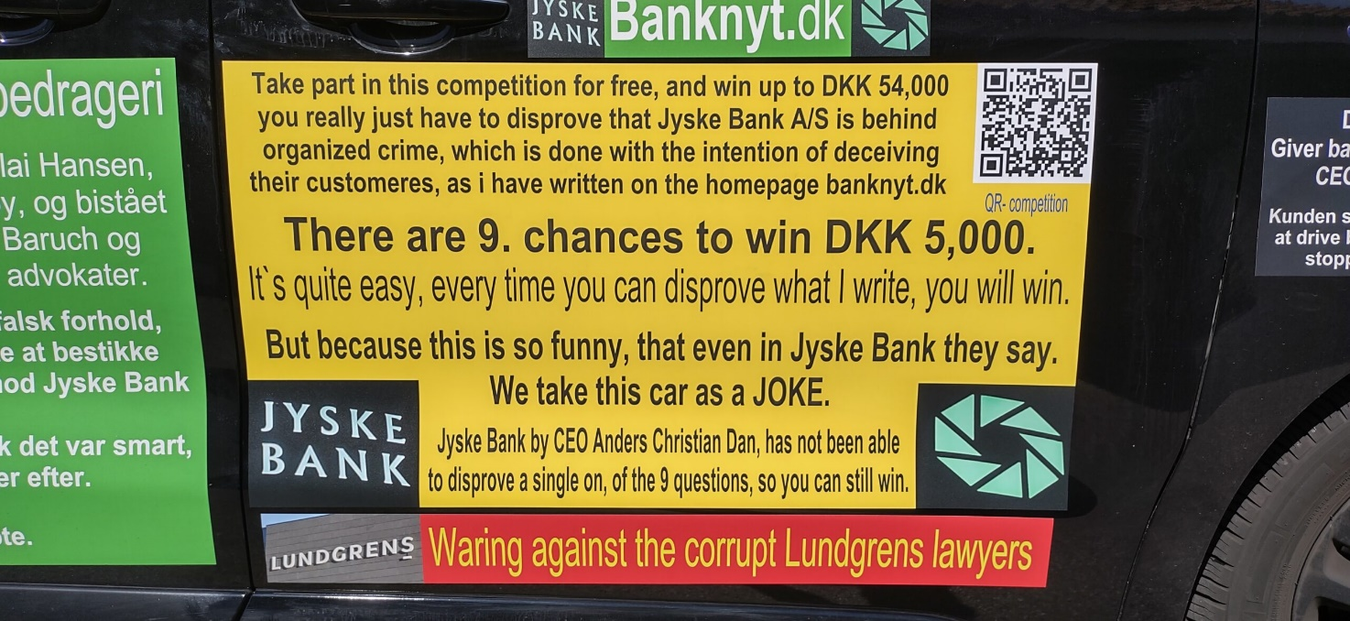 http://banknyt.dk/23-07-2022-here-is-the-competition-to-disprove-that-jyske-bank-is-a-criminal-bank-23-07-2022-time-13-43-has-been-sent-to-jyske-bank-and-the-danish-state/[/caption]

If only one of you can disprove my evidence that. Jyske Bank is behind organized crime.
And that.
Jyske Banks A/S has committed fraud.
And that.
Jyske Banks A/S has forged documents.
And that.
Jyske Banks A/S has paid bribes to Lundgren's lawyers so that Lundgren's lawyers could not present the client's fraud and false accusations against Jyske Banks A/S
Then you are all offered to be able to get paid 5.000 dkk and a 20% bonus for being able to disprove each of my first 9 claims in the competition.

The Executive Board of the National Bank of Denmark.
National Bank Director Signe Krogstrup, National Bank Director Lars Rohde, National Bank Director Per Callesen.
Formand: Professor Christian Schultz
Næstformand: Departementschef Michael Dithmer
Valgt af repræsentantskabet
Adm. direktør Per Bank
Formand for DSR Grete Christensen
Folketingsmedlem Jakob Ellemann-Jensen
Folketingsmedlem Anne Paulin
Professor Christian Schultz
Departementschef Michael Dithmer
Departementschef Johan Legarth
Formand: Professor Christian Schultz
Næstformand: Adm. direktør Anne Hedensted Steffensen
Folketingsmedlem Lisbeth Bech-Nielsen. SF. lisbeth.bech-nielsen@ft.dk
Folketingsmedlem Kristian Thulesen Dahl. UFG tidligere DF. kristian.thulesen.dahl@ft.dk
Folketingsmedlem Jakob Ellemann-Jensen. V. Venstre. jakob.ellemann-jensen@ft.dk
Folketingsmedlem Jens Joel. S. Socialdemokratiet. jens.joel@ft.dk
Folketingsmedlem Sophie Løhde. V. Venstre. sophie.lohde@ft.dk
Folketingsmedlem Anne Paulin. S. Socialdemokratiet. anne.paulin@ft.dk
Folketingsmedlem Sofie Carsten Nielsen. RV. Radikale Venstre. sofie.carsten.nielsen@ft.dk
Folketingsmedlem Troels Lund Poulsen. V. Venstre. troels.poulsen@ft.dk
Departementschef Michael Dithme. Erhvervsministeriet. dc@em.dk em@em.dk
Departementschef Johan Legarth. i Justitsministeriet. jm@jm.dk
Adm. direktør Jens Bjørn Andersen.
CEO Connie Astrup-Larsen
Adm. direktør Per Bank
Formand for DSR Grete Christensen
Adm. direktør Asger Enggaard
Adm. direktør Kathrine Forsberg
CEO Kristian Hundebøll
Formand Claus Jensen
Formand for Forbrugerrådet Tænk Anja Philip
Formand Lizette Risgaard
Professor Philipp Schröder
Professor Christian Schultz
Adm. direktør Anne Hedensted Steffensen
Adm. direktør Christian Woller
CEO Gitte Pugholm Aabo
You can all get an extra 20% bonus, just to disprove my 9 claims
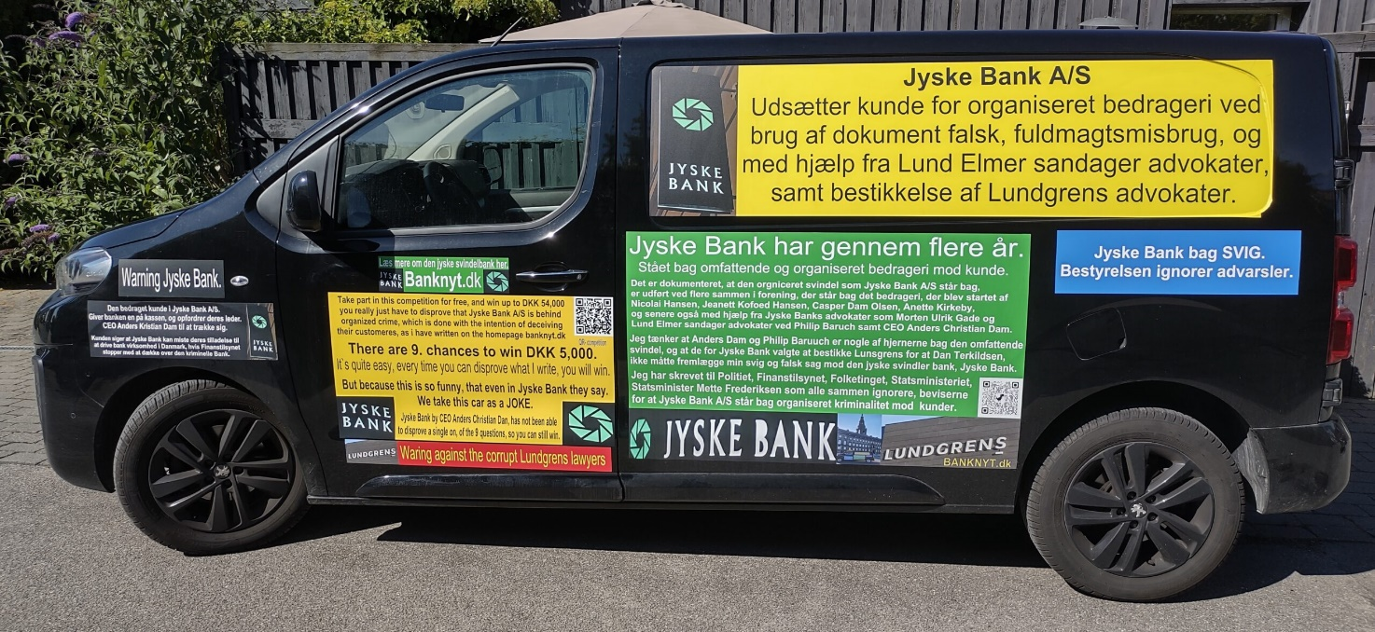
[caption id="attachment_21997" align="alignnone" width="2560"]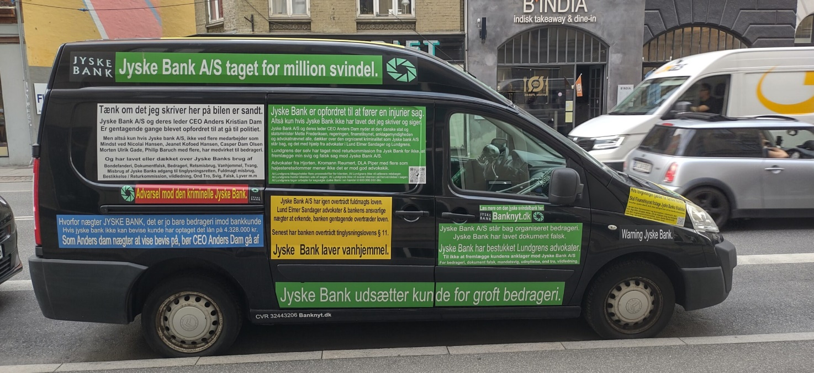 Jyske Bank employees say to us it's just a joke.
Jyske Bank's employees at Gammel Kongevej 136 lie and say the case against Jyske Bank has been lost in the high court, even though the case has not even been scheduled inu.[/caption][caption id="attachment_21532" align="alignnone" width="2560"]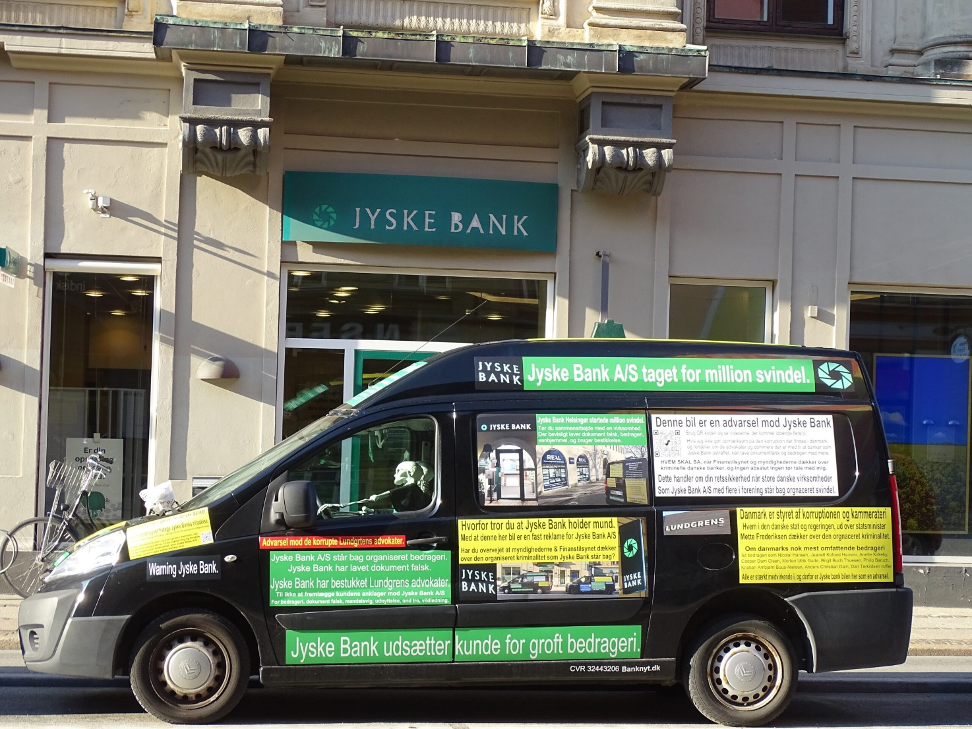 Do you know the Jyske bank car, which is here parked outside Jyske Bank at Gammel Kongevej 136.
Ask Jyske bank if what is written on the car is true, since not a single one dares to confront Carsten.[/caption]

See the 9 prizes of DKK 5,000. and then with a bonus of 20% if you can disprove my evidence for Jyske Bank A/S's many criminal offences.
If the Danish Nationalbank, and the authorities, still ignore my information about Jyske bank committing fraud and other punishable offences, I will sue Denmark for violating my legal certainty and opposing law and order in Denmark.

Regards
Carsten Storbjerg Skaarup
Soevej 5.
3100 Hornbaek
Denmark
+4522227713
mail carsten.storbjerg@gmail.com
carsten.storbjerg.skaarup@gmail.com
banknyt@gmail.com

4 attached files in the mail.
30-06-2022. Competition for 45,000 Danish kroner for you who can disprove, That Jyske bank is a criminal organization,
07-08-2022. An exclusive offer for Denmarks National Bank, I have decided that you can get 20% in bonus prime if you can disprove all my evidence that Jyske Bank is a criminal organization
Frontpage banknyt 08-08-2022. Is Jyske Bank about to close After all, state protection cannot last forever.
04-08-2022. Danmarks Nationalbank at Nationalbank Director Lars Rohde.

