Backoffice Jyske Bank 2022.

Afdelingen
Vi er med til at skabe rammerne for, at kollegaerne i afdelingsnettet kan give kunderne god service og rådgivning.

Ring til os

89 89 89 89

Adresse
Jyske Bank - Backoffice
Vestergade 8-16
8600 Silkeborg

Se kørselsvejledning [PDF]

Snak med en af vores 45 medarbejdere

Ledelse

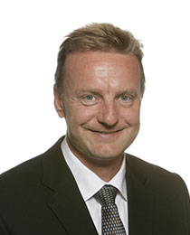

Henrik Møller Nielsen
Head of Department
89 89 28 30hmn@jyskebank.dk

Frank Hjorth Assens
Head of Section, FX, MM and Derivatives
+45 89 89 96 49frank.assens@jyskebank.dk
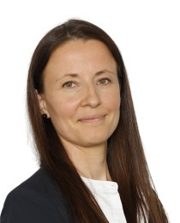

Helle Varming
Head of Section, Settlement og Custody
89 89 73 59hv@jyskebank.dk

Custody Services

Andreas Hansen
Senior Operations and Innovation Officer
+45 89 89 73 70andreas.hansen@jyskebank.dk

Hans Straarup
Assistant Operations and Innovation Officer
89 89 73 61hast@jyskebank.dk
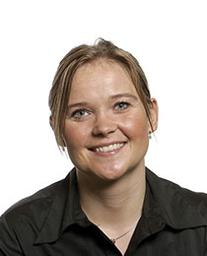

Karin Møller Jensen
Operations and Innovation Officer
89897326km@jyskebank.dk

Marius Jensen Lundorf
Operations og Innovations Officer
89 89 73 81malu@jyskebank.dk

Mette M. Jakobsen
Operations and Innovation Officer
89 89 73 52mette-mj@jyskebank.dk

Michael Bruun Jensen
Operations and Innovation Officer
89892043mbruun@jyskebank.dk

Poul Nørbjerg
Senior Operations and Innovation Officer
89897382pon@jyskebank.dk

Svend Dybkjær
Senior Operations and Innovation Officer
89897360svend.dybkjaer@jyskebank.dk

Settlement

Alexander Bisbo
Assistant Operations and Innovation Officer
89897329albi@jyskebank.dk

Daniel Mortensen
Operations and Innovation Officer
89897268daniel.mortensen@jyskebank.dk
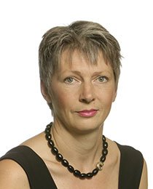

Hanne Bremer Sørensen
Operations and Innovation Officer
89 89 73 76habs@jyskebank.dk
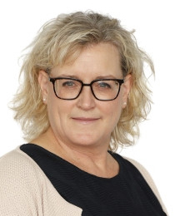

Helene Højrup Ebbesen
Assistant Operations and Innovation Officer
89897363hhe@jyskebank.dk

Laura Thomsen
Assistant Operations and Innovations Officer, Settlement
89897358lath@jyskebank.dk

Lene Ravn
Assistant Operations og Innovation Officer
89 89 73 71lslr@jyskebank.dk

Mark Binnerup Andersen
Operations and Innovation Officer
89897351mban@jyskebank.dk
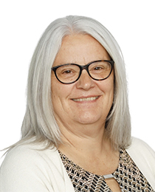

Nanna Schmidt Jespersen
Operations and Innovation Office
89 89 73 65nsj@jyskebank.dk
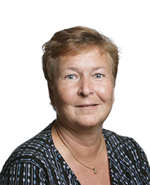

Outi Marjaana Møller
Assistant Operations and innovations Officer
89 89 73 75outi@jyskebank.dk
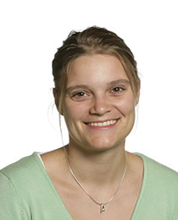

Sanne Boesen
Operations og Innovation Officer
89 89 73 72sanne.boesen@jyskebank.dk

Thomas Bønnelykke Dalgaard
Operations And Innovation Officer
89897373trd@jyskebank.dk

Valuta

Anne Nygaard Henriksen
Operations og Innovation Officer
89897315anh@jyskebank.dk

August Bylov
89897301auby@jyskebank.dk

Christian Mønster Matthiesen
89897310cmm@jyskebank.dk
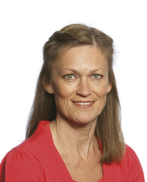

Eva E. Pausgaard
Senior Operation and Innovation Officer
89 89 73 17evapaus@jyskebank.dk

Helle Faurholt
Operations and Innovation Officer
89897314helle-faurholt@jyskebank.dk
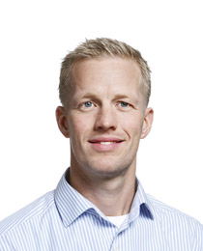

Henrik Buus Knudsen
Operations and Innovation Officer
89 89 73 24hbk@jyskebank.dk

Karin Staghøj
Senior Operation and Innovation Officer
89 89 73 02karin-staghoj@jyskebank.dk

Kasper Lyngholm
Operations and Innovation Officer
89 89 73 06kasper.lyngholm@jyskebank.dk

Lars-Ole Nordby
Student Assistent - Backoffice
89897355lano@jyskebank.dk

Liselotte Kierkegaard
Operations and Innovation Officer
89 89 73 07kierkegaard@jyskebank.dk

Liv Nygaard Danielsen
89897323lida@jyskebank.dk
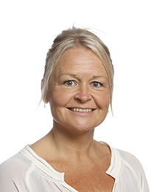

Lotte Hørning Papsø
Operations and Innovation Officer
89897311l-papsoe@jyskebank.dk
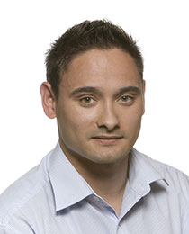

Marc Lennards
Operations and Innovation Officer
89 89 73 08marcl@jyskebank.dk

Marianne Nedergård
Assistant Operations and Innovation Officer
89 89 73 21marianne-nedergaard@jyskebank.dk

Mark Øhlenschlæger
89897332maoh@jyskebank.dk

Martin Bertelsen
Operations and Innovation Officer
89897320mibe@jyskebank.dk
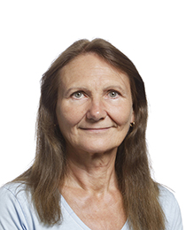

Mitha Rabes Pedersen
Assistant Operations and Innovation Officer
89 89 73 22mitha@jyskebank.dk

Peter Lykkemark
Operations and Innovation Officer
89897325ply@jyskebank.dk

Roger Noel Bonney
Operations and Innovation Officer
89 89 73 27bonney@jyskebank.dk
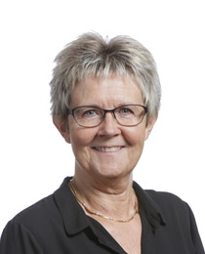

Suzanne Lyngholm
Operations and Innovation Officer
89 89 73 09lyngholm@jyskebank.dk
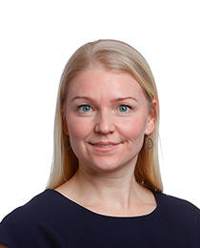

Tina Tvedesøe
Senior Operations and Innovation Officer
89898684ttv@jyskebank.dk
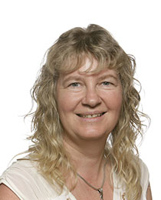

Tove Pleth Damhave
Operations and Innovation Officer
89 89 73 04damhave@jyskebank.dk
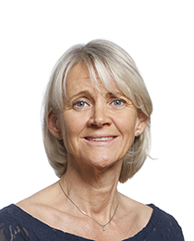

Ulla Birch Biede
Operations and Innovation Officer
89 89 73 18biede@jyskebank.dk

